I/ Calculate body fitness

1. BMI (Body Mass Index): BMI = W/H^2

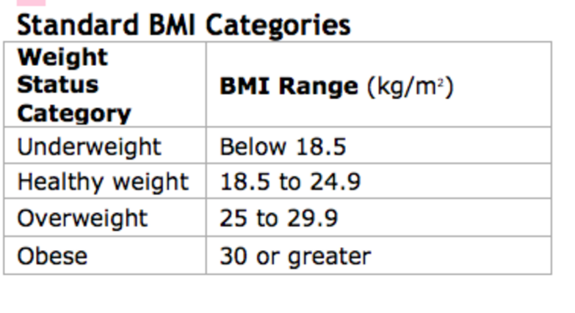

1. TDEE (Total Daily Energy Expenditure): **TDEE = BMR x R**

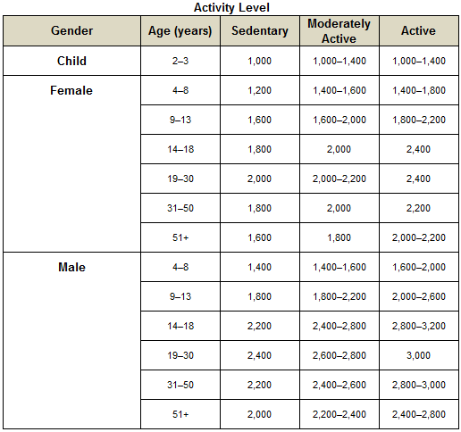

1. BMR (Basal Metabolic Rate)

Male: BMR = (13,397 x W) + (4,799 x H) – (5,677 x A) + 88,362

Female: BMR = (9,247 x W) + (3,098 x H) – (4,330 x A) + 447,593

W: weight in kg

H: height in cm

A: age in years

R: number of activity factors calories. R number will follow the list below:

Sedentary (little to no exercise + work a desk job) = 1.2

Lightly Active (light exercise 1-3 days / week) = 1.375

Moderately Active (moderate exercise 3-5 days / week) = 1.55

Very Active (heavy exercise 6-7 days / week) = 1.725

Extremely Active (very heavy exercise, hard labor job, training 2x / day) = 1.9

II/ Calories

III/ Type of users

* Normal people
* Sick people
* Body builder
* Dieter
* Worker

IV/Information overview:

1. How old are you?
2. What is your gender?
3. What is your weight? (Kilograms)
4. What is your height?
5. What is your nationality?
6. How often do you exercise? (In a week. EX: 0 day, 1-3 days, 3-5 days, etc.)
7. Which mode would you want to choose? (Lose weight, gain weight, keep fit)
8. Do you have any disease? (Flu, Cold, Stomachache)
9. Are you allergic to anything? (butter, milk, egg, peanut, Shellfish, fish, etc.)

V/ Illness & How to cure?

1. Flu

* Stay home and get plenty of rest
* Drink plenty of fluids
* Treat aches and fever
* Take care of your cough
* Sit in a steamy bathroom
* proper nutrition

1. Cold

* Stay hydrated
* Rest
* Soothe a sore throat
* Combat stuffiness
* Relieve pain
* Try honey
* Sip warm liquids

1. Stomachache

* Place a hot water bottle or heated wheat bag on your abdomen.
* Soak in a warm bath. Take care not to scald yourself.
* Drink plenty of clear fluids such as water.
* Reduce your intake of coffee, tea and alcohol as these can make the pain worse.
* Get plenty of rest.
* Try over-the-counter antacids, to help reduce some types of pain.
* Take mild painkillers such as paracetamol.

NOTE: Those solution just help you to reduce the effect of the disease. You should come to the hospital as soon as possible.